How to Setup email on iPhone
To go ‘Settings’
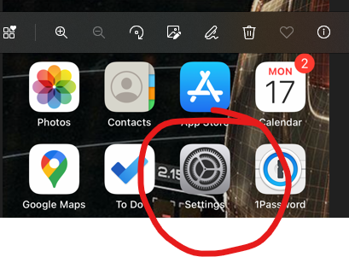

Scroll down until you see ‘Mail’
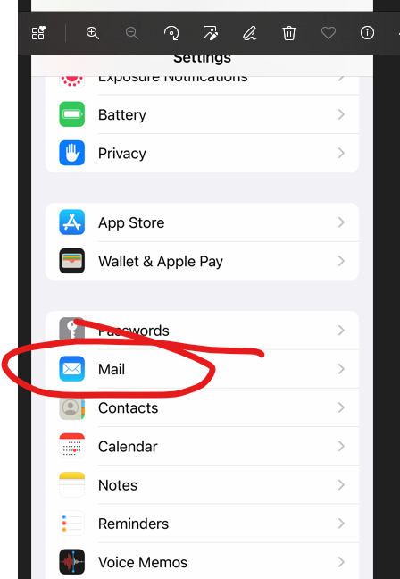

Select ‘Accounts’
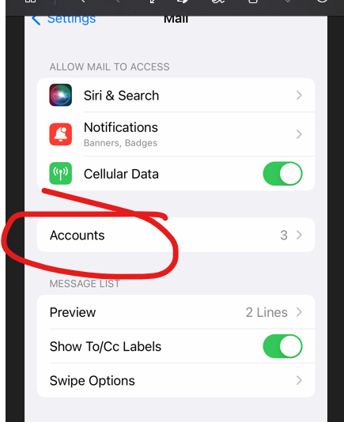

Now select ‘Add Account’
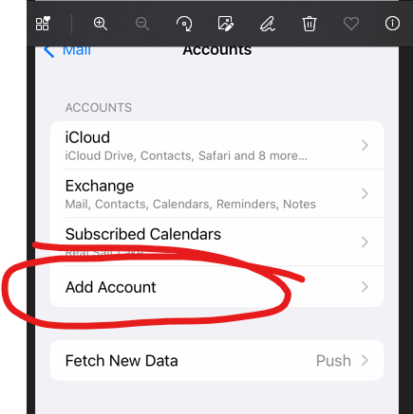

Select ‘Microsoft Exchange’
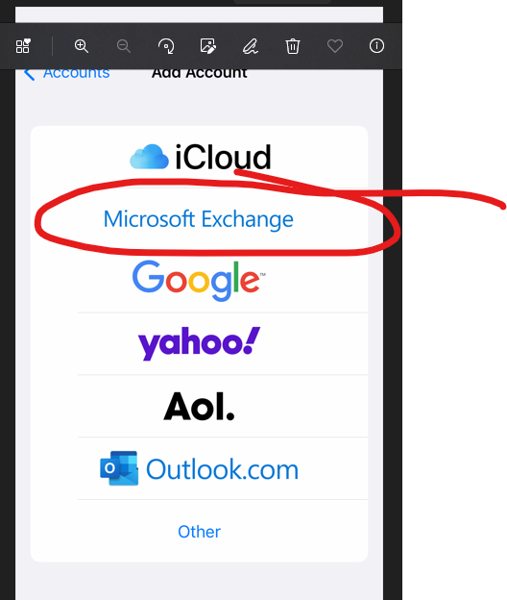

Enter your email address and a description. I recommend ‘Work Email’.
Select ‘Configure Manually’
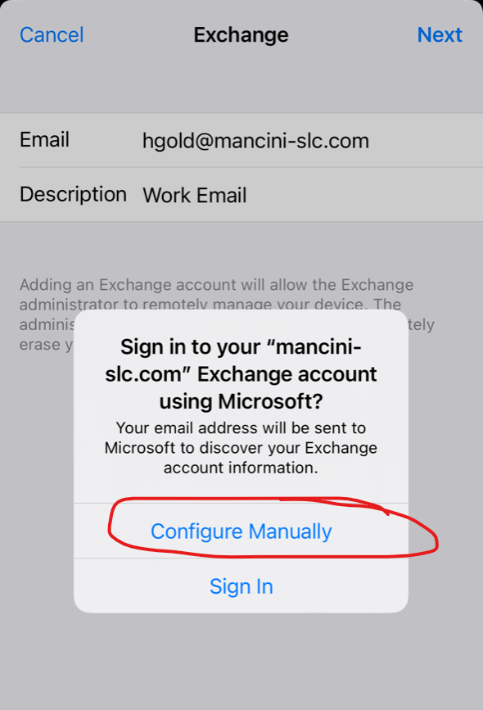

Enter your new email password.
Select ‘Next’
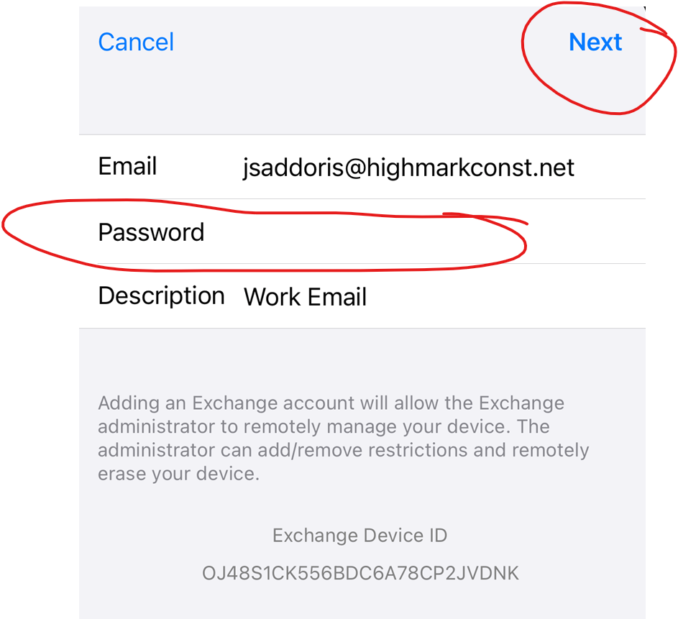

Enter the information as seen in the picture below:
- Email: Your email address
- Server: email.frontpoint-it.com
- Domain: empty
- Username: Your email address
- Password: Your email password
Then select ‘Next’
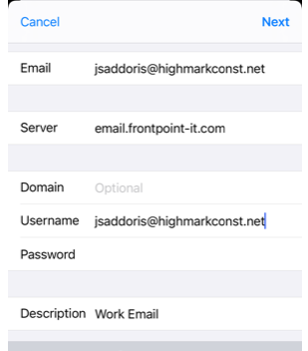

Confirm all the selections are Green and then select ‘Save’ or ‘Next’
