How to Set up Outlook for Mac
Mac Edition
Open Outlook and go to: Outlook | Preferences…
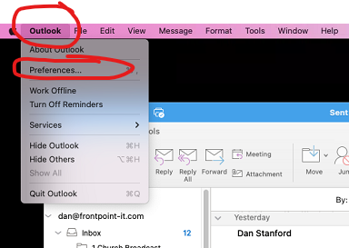

Select ‘Accounts’
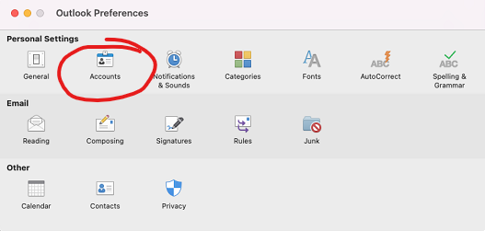

Select ‘+’ sign to add a new account
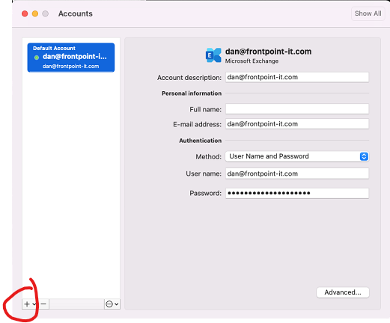

Enter your email address
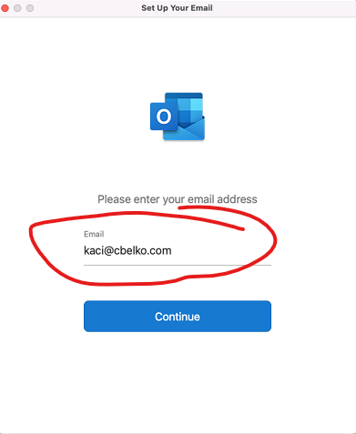

Select ‘Choose the Provider’
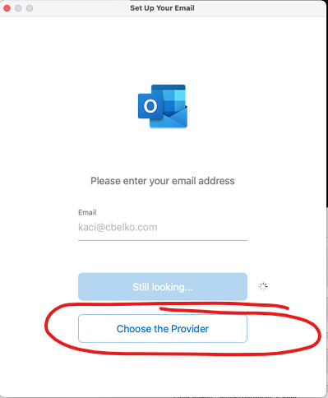

Select ‘Exchange’
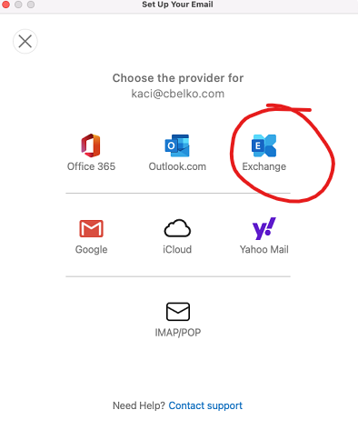

Enter the following:
- DOMAIN\username or Email -> your full email address
- Password -> your email password
- Server (optional) -> email.frontpoint-it.com
