How to Set up Outlook for Windows
Start the Outlook Program
Make sure your email address is correct and then select ‘Advanced options’ and then select ‘Let me set up my account manually’ and then select ‘Connect’
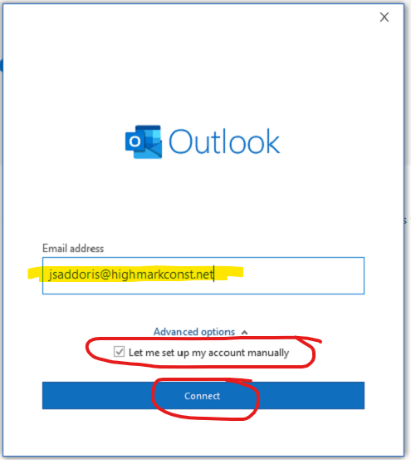

Select ‘Exchange’
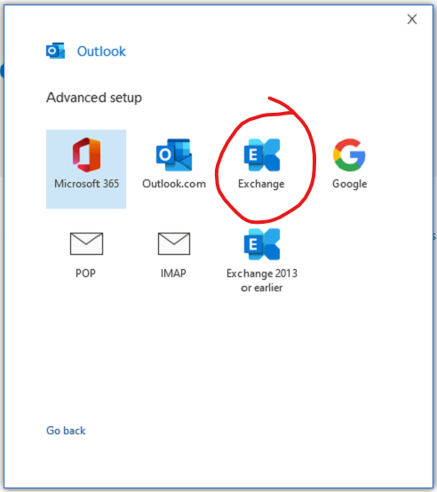

When prompted select ‘Don’t ask me about this website again’ and then select ‘Allow’
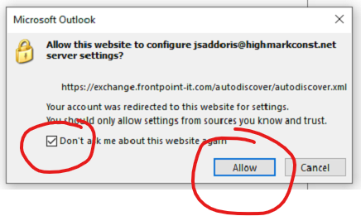

Select ‘Remember my credentials’
Enter your email password and then select ‘Ok’
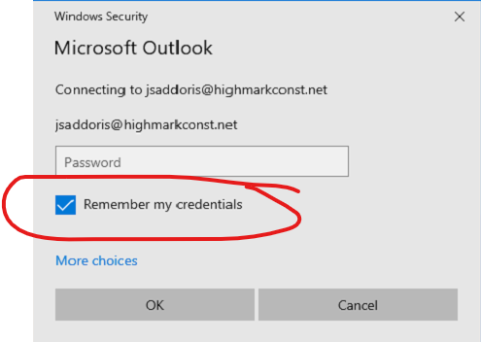

Select ‘Next’
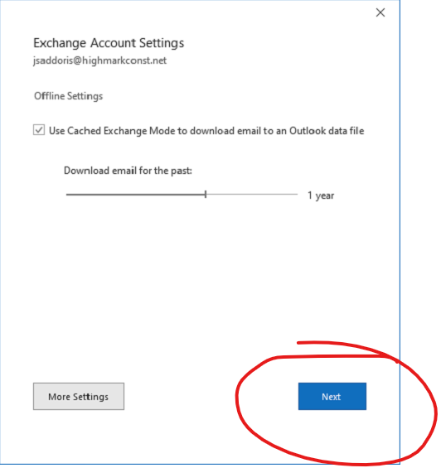

Select ‘Done’
