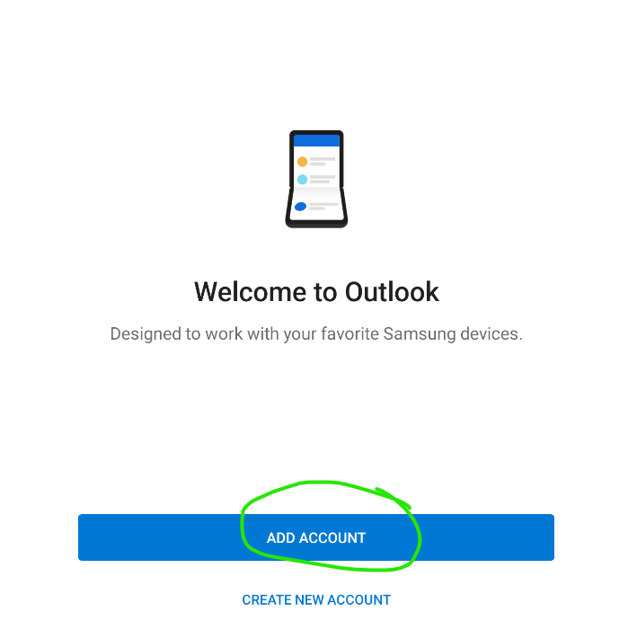

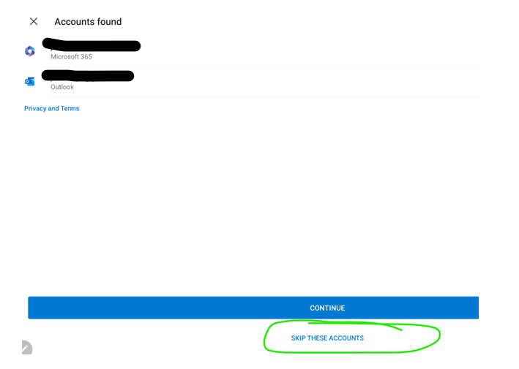

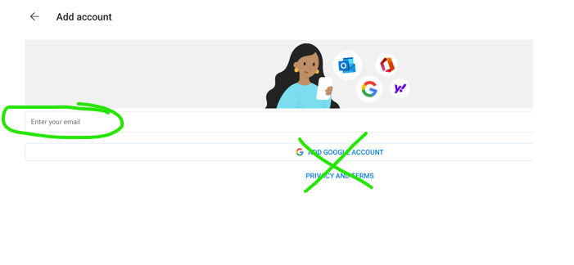

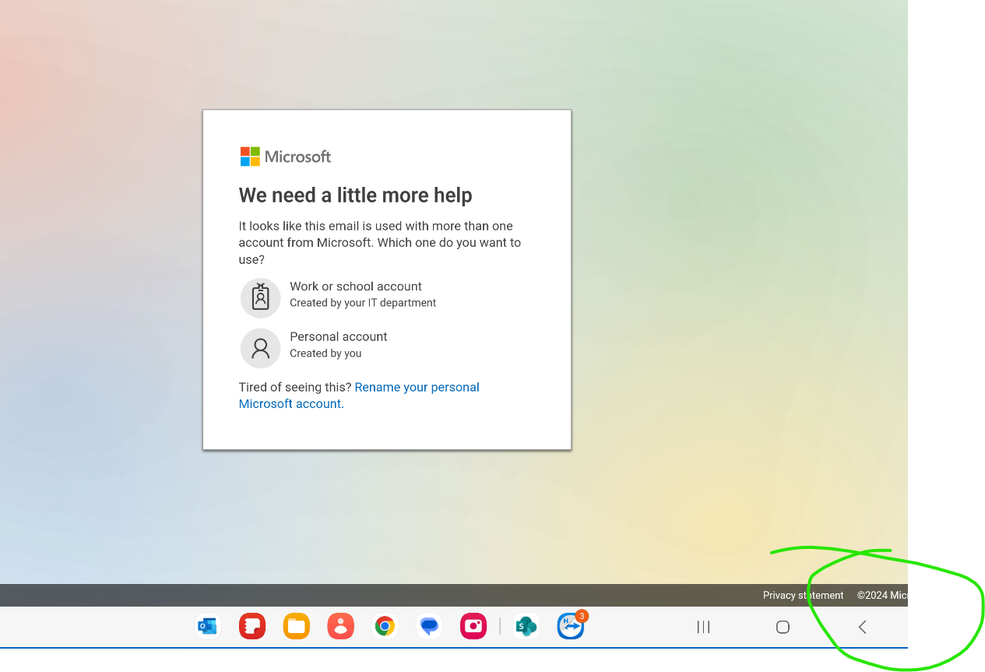

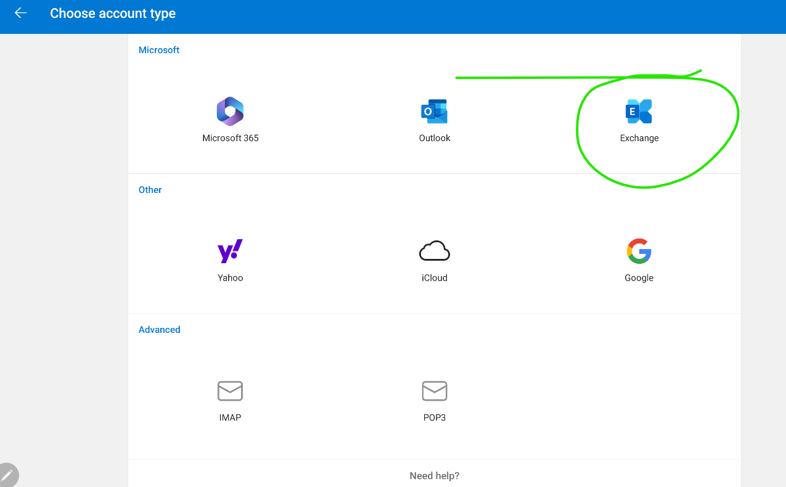

NOTE: You may need to select ‘Advanced Settings’
Email Address: YOUR EMAIL ADDRESS
Password: YOUR EMAIL PASSWORD
Server: email.frontpoint-it.com
Domain: Nothing/Empty/Leave Blank/Do not put anything in this field
Username: YOUR EMAIL ADDRESS

